Factory service breakdown

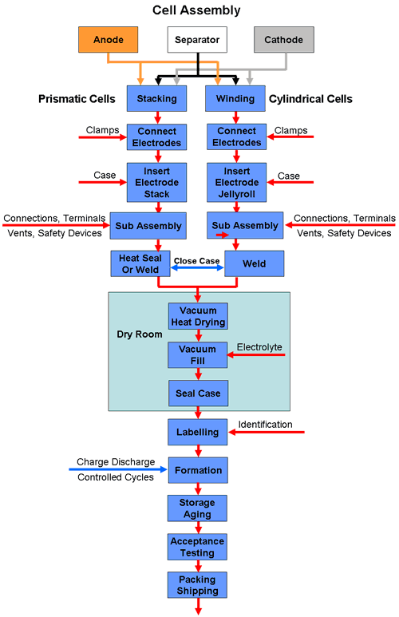

[**http://www.mpoweruk.com/battery_manufacturing.htm**](http://www.mpoweruk.com/battery_manufacturing.htm)

<https://learn.sparkfun.com/tutorials/how-lithium-polymer-batteries-are-made>

A chemical slurry (which will become an electrode) is mixed

A machine deposits the slurry into large squares on a sheet of metal substrate

The metal sheet is passed through a curing oven, solidifying the slurry into electrodes

A machine cuts electrodes to their proper size

A machine stacks anodes and cathodes with a separator between each pair

The stacks are put into a housing, which is heat sealed on 3 sides.

The cells are evacuated, pumped with electrolyte, and fully sealed

A protection circuit is attached to the cells, and the cells are packaged together into a complete battery

The batteries undergo charge/discharge cycles

<http://w3.siemens.com/markets/global/de/batterieherstellung/Documents/webfeature/start_en.htm>

Services involved:

Slurry mixing

Slurry deposition

Electrode curing

Electrode cutting

Electrode stacking

Stack packing

Electrolyte filling

Cell sealing

Protection circuit installment

Battery assembly

Battery charge cycles

Batch packaging

Electrode stacking machine subservices:

Actuators:

Pneumatic compressor (vacuum gripper, stack clamps)

Pneumatic valves

Pressure regulator

Pneumatic pistons (holding clamps) – linear actuators

Separator tensioner(?)

Stepper/Servo Motors (grippers, carriage) – linear actuators

Sensors:

Pressure gauges (pneumatic reservoir, vacuum grippers, electronic pressure regulators)

Linear position sensors (encoders/servo potentiometers)